This document is merely to point out the differences in confessional count numbers between my findings and the official numbers posted on Survivor Sucks. The guidelines I use can be found [here](https://docs.google.com/document/d/18ofsPiVWxSejzSjEGlU8KEx4Og2ddEJScCV23RsCPIA/edit?usp=sharing).

**Survivor Sucks Season 05 Counts** ([link](https://goo.gl/photos/SNNj4oSPxwiZE6ef9))

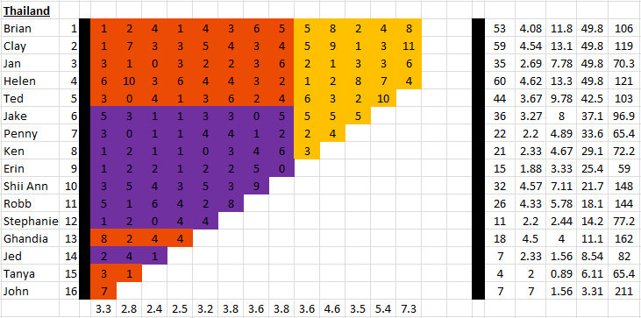

**My Season 05 Counts** (link)

**Differences**

[Episode 01](https://docs.google.com/document/d/1fnQp31vpa65Lx5QgLXS2kGDBtDsBE9LLRRykzCEGKdk/edit?usp=sharing)

* **Helen 5 (-1)** I got a total of 5 confessionals for Helen instead of the established 6. No significant gaps.
* **Robb 6 (+1)** I got a total of 6 confessionals for Robb instead of the established 5. No significant gaps.
* **Ghandia 10 (+2)** Confessional #41 has a 10s gap.
* **John 8 (+1)** Confessionals #39 & #40 are voice overs and there’s an 11s gap in between them.

Episode 0

**No Change**

* Episode

|  |  |  |
| --- | --- | --- |
| **Castaway** | **Count** | **Change** |
|  |  |  |
| **Total** |  |  |

**Revised Sucks Counts** (link)